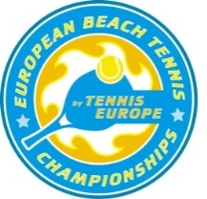
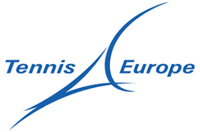

2017

EUROPEAN BEACH TENNIS CHAMPIONSHIPS
Sozopol, Bulgaria

Nomination Form

JUNIORS

National Association:

Responsible Person:

Mobile phone number:

Email address:

1. Mobile number captain/player: Name: Number:

2. Mobile number player: Name: Number:

Boys’ Doubles 18&Under

 | First Name | Surname | Date of Birth (dd/mm/yy) | Email Address
1
2
3
4
 | PLAYER 5 & 6 - only BUL (host country)
5
6

Girls’ Doubles 18&Under
 | First Name | Surname | Date of Birth (dd/mm/yy) | Email Address
1
2
3
4
 | PLAYER 5 & 6 - only BUL (host country)
5
6

Mixed Doubles 18&Under
 | First Name | Surname
1
2
3
4

PLAYER 5 & 6 - only BUL (host country)
5
6

Captain (mandatory/copy of passport required)
 | First Name | Surname | Email Address
 | Mobile telephone number

Travel Details
Arrival of players and captain Date, time, flight: | Departure Date, time, flight:

We hereby confirm the eligibility of the above nominated players in accordance with the ITF Beach Tennis Tour Rules & Regulations. Furthermore, we confirm that the above nominated players will comply with the European Beach Tennis Championships conditions/requirements and age eligibility rules, which are outlined in the 2017 Circulars 1 and 2.

Name:

Signature:

National Association Stamp and Date:

To be returned by Tuesday 8th August 2017
to Tennis Europe/Nadja Koran nadjak@tenniseurope.org

